**Homework 5 - AJMN100**

**Page 430 #8.81**

> Cap_len <- c(78,66,65,63,60,60,58,56,52,50)

> qqnorm(Cap_len)

> qqline(Cap_len)

We Obtain the following graph

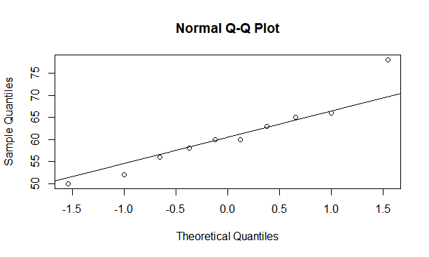

> n <- 10; n

[1] 10

> u <- mean(Cap_len); u

[1] 60.8

> s <- sd(Cap_len); s

[1] 7.969386

> #95% CI

Here the variance is unknown for the population of all lobsters.

> q <- qt(1-0.025,n-1); q

[1] 2.262157

> CImax <- u + q*(s/sqrt(n)); CImax

[1] 66.50096

> CImin <- u - q*(s/sqrt(n)); CImin

[1] 55.09904

So, the 90% CI interval is [55.09, 66.50]

**Interpretation**: I am 90% confident that the average carapace length of all T. orientalis lobsters caught in the seas near Singapore is between 55.09mm and 66.50mm.

**Page 431 #8.83**

1. Under the resting condition, we have

> u_r <- 14.5; s_r <- 3.92; n_r <- 10

> u_c <- 11.1; s_c <- 3.98; n_c <- 10

For a 95% CI:

> q <- qt(1-(1-.95)/2, n_r+n_c-2); q

[1] 2.100922

> sp2 <- ((n_r-1)*(s_r^2)+(n_c-1)*(s_c^2))/(n_r+n_c-2); sp2

[1] 15.6034

> CI1 <- u_r - u_c - q * sqrt(sp2*(1/n_r + 1/n_c)); CI1

[1] -0.3113726

> CI2 <- u_r - u_c + q * sqrt(sp2*(1/n_r + 1/n_c)); CI2

[1] 7.111373

**Thus, the CI is [-0.31, 7.11]**

1. At 80% of maximal oxygen (O2) consumption, we have

> u_r <- 12.2; s_r <- 3.49; n_r <- 10

> u_c <- 11.5; s_c <- 4.95; n_c <- 10

For a 90% CI:

> vr <- (s_r^2)/n_r; vc <- (s_c^2)/n_c

> v <- ((vr + vc)^2)/(((vr)^2)/(n_r-1) + ((vc)^2)/(n_c-1)); v

[1] 16.1748

> v <- floor(v); v #Round down

[1] 16

> q <- qt(1-(1-.90)/2, v); q

[1] 1.745884

> sp2 <- ((n_r-1)*(s_r^2)+(n_c-1)*(s_c^2))/(n_r+n_c-2); sp2

[1] 18.3413

> CI1 <- u_r - u_c - q * sqrt(sp2*(1/n_r + 1/n_c)); CI1

[1] -2.643839

> CI2 <- u_r - u_c + q * sqrt(sp2*(1/n_r + 1/n_c)); CI2

[1] 4.043839

**Thus, the CI is [-2.64, 4.04]**

1. Interpretation of the CI intervals in a) and b)
   1. **Interpretation**: I am 95% confident that the difference in the mean compartment pressures between runners and cyclist under the resting condition is between -0.31 and 7.11 unit of pressure.  
        
      Also, there’s no significant difference between the mean compartment pressures of runners and cyclist since 0 can be found within our CI.
   2. **Interpretation**: I am 90% confident that the difference in the mean compartment pressures between runners and cyclist who exercise at 80% of maximal oxygen (O2) consumption is between -2.64 and 4.04 unit of pressure.  
        
      Also, there’s a significant difference between the mean compartment pressures of runners and cyclist since 0 cannot be found within our CI

**Page 430 #8.81**

Similar to #8.81 let us find a 90% confidence interval for the population variance σ2

We have:

> Cap_len <- c(78,66,65,63,60,60,58,56,52,50)

We assume normality of our distribution.

> n <- length(Cap_len); n

[1] 10

> u <- mean(Cap_len); u

[1] 60.8

> s <- sd(Cap_len); s

[1] 7.969386

For a CI of 90% of our pop. Variance:

> alpha <- 1-.90

> CImin <- ((n-1)*s^2)/qchisq(1-alpha/2,n-1); CImin

[1] 33.78455

> CImax <- ((n-1)*s^2)/qchisq(alpha/2,n-1); CImax

[1] 171.9039

Thus, the 90% CI for σ2 is [33.78, 171.90]

**Interpretation**: I am 90% confident that the population variance of the carapace length of all T. orientalis lobsters caught in the seas near Singapore is between 33.78mm2 and 171.9039mm2.